Jenkins FreeStyle Project:

Step1: open jenkins webpage create a freestyle project (job1)



Step2: open job1 add source code from github

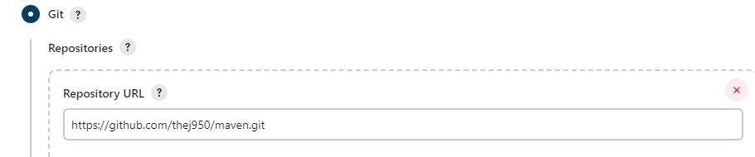

Step3: goto build section build the job with maven package command

Here you need maven plugins

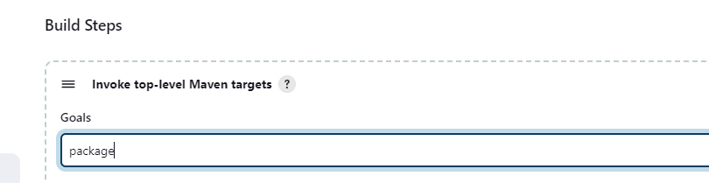

Step4: deploy war files into qa servers

Here you need pluggins like Deploy war or ear pluggin

Make sure provide username and password in qa server and prod server

To deploy war files inside qa ad prod server (/var/lib/tomcat9/webapps/ )



Restart tomcat9 service after modify it

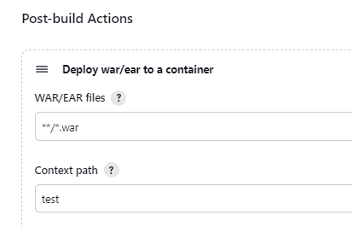

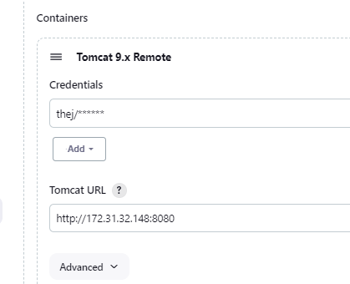

After deploying war files inside /var/lib/tomcat9/webapps a context path will be shown as .war file by using that we can able access from server

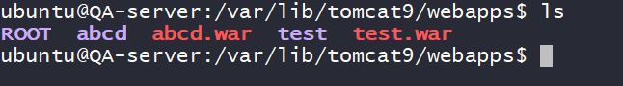

Step5: Now create a testing job to perform testing for our code download testing scripts in jenkins

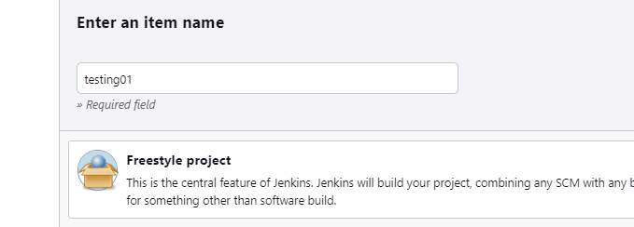

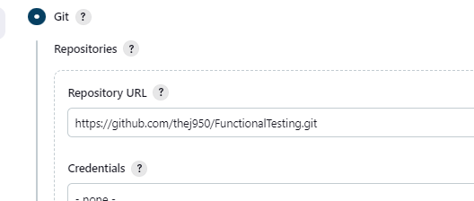

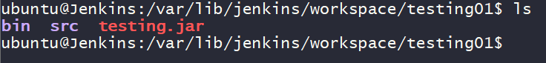

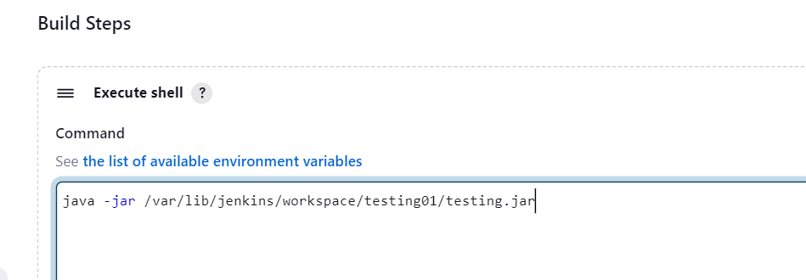

step6: Now build other jobs from Developement job like (job1)







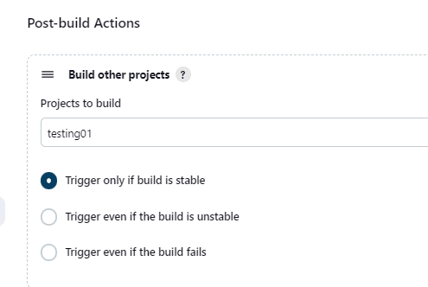

From here when you build job1 automatically after completing job1 it will build testing job also

Step7: Now goto job1 and make archive war file in jenkins to send to another server





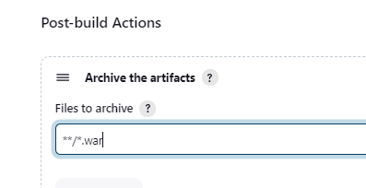

Step8: Now goto testing job setup copy files from another machine

For this we need a pluggin called copy artifacts plugin



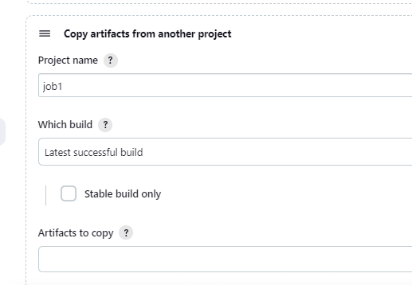

Step9: deploy into prod server



